**Student Name: Shinde Smita Shahaji UID: 20BCS4643**

**Branch: CSE-(IOT) Section/Group:IOT- Group B**

**Subject Name: Digital Electronics Date of Performance:18/03/2021**

**AIM**

Design a person counter for a hall such that at any point of time it can display the total no of persons in the hall.

**Note: Count can go upto 99 persons**.

**Task to be done**

*(Objective of the task to be explained)*

Design a light-based object counter with a 7-segment display (CD4026).

**Requirements**

*(Hardware and software requirements)*

# Software –

Tinker cad.

# Hardware –

7-segment display (CD4026).

Breadboard

|  |  |  |
| --- | --- | --- |
| Sr.no | Apparatus | Quantity |
| 1. | 4-bit binary counter | 1 |
| 2. | 7thsegment decoder(cathode) | 1 |
| 3. | Photoresistor (LDR) | 1 |
| 4. | Resister | 2 |
| 5. | Power supply | 1 |
| 6. | Connecting wires | 26 |

**Circuit diagram/ Block diagram**

*(Insert circuit diagram here)*

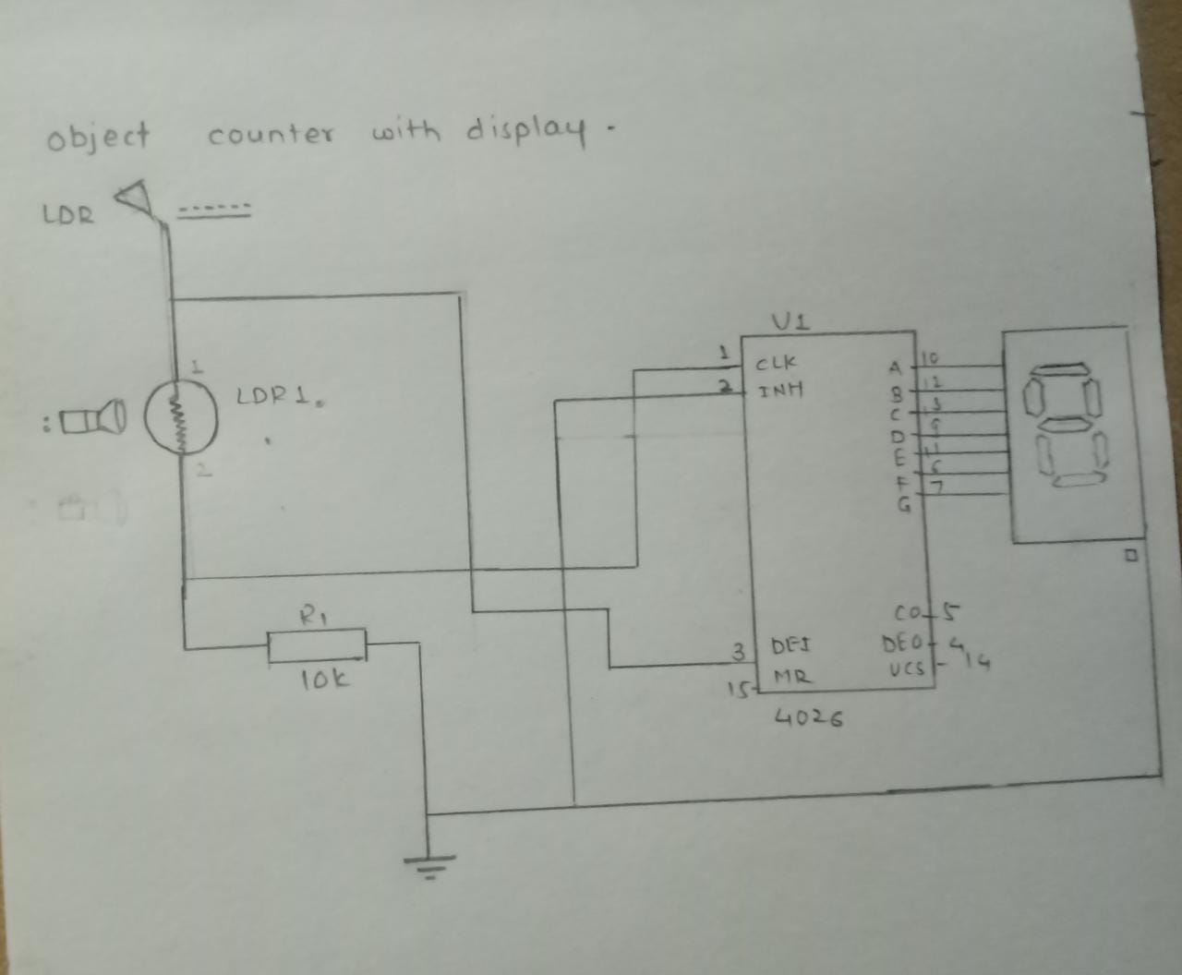

Circuit diagram on tinker-cad 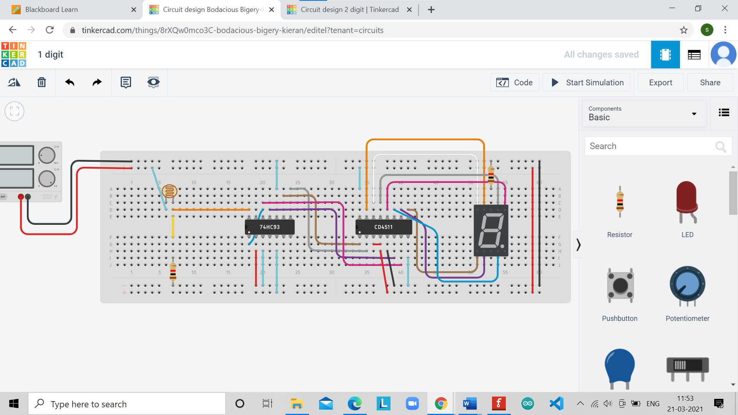

**Simulation Results:**

*(Insert simulation results)*

Display of zero digit at starting of simulation

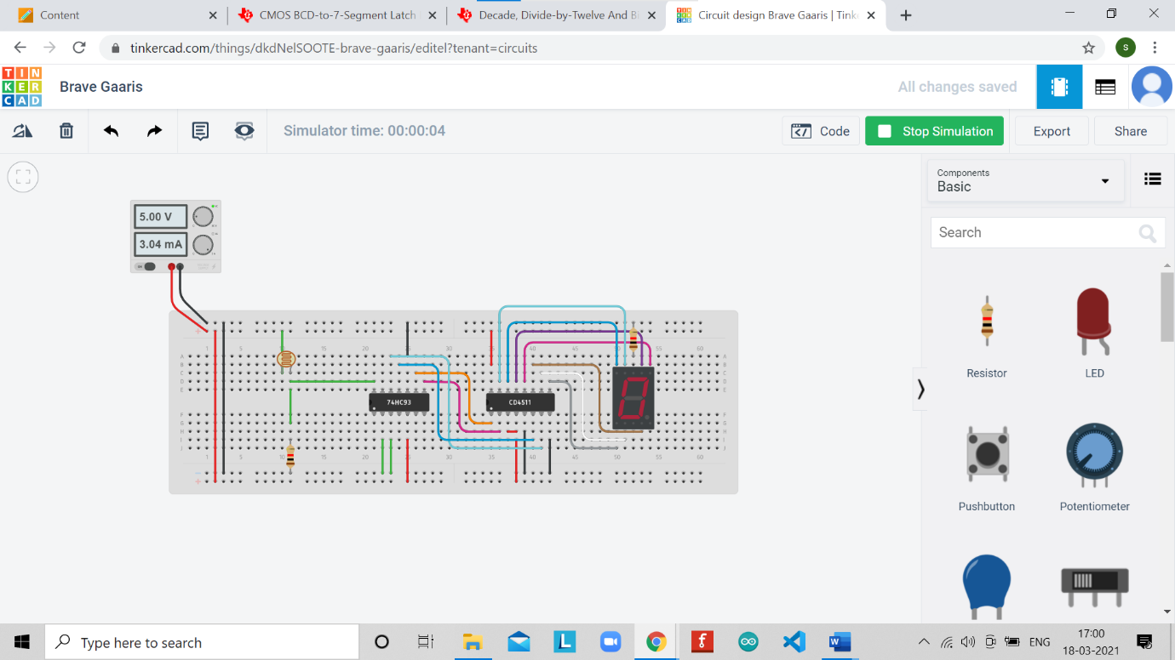

Display of digit number 1

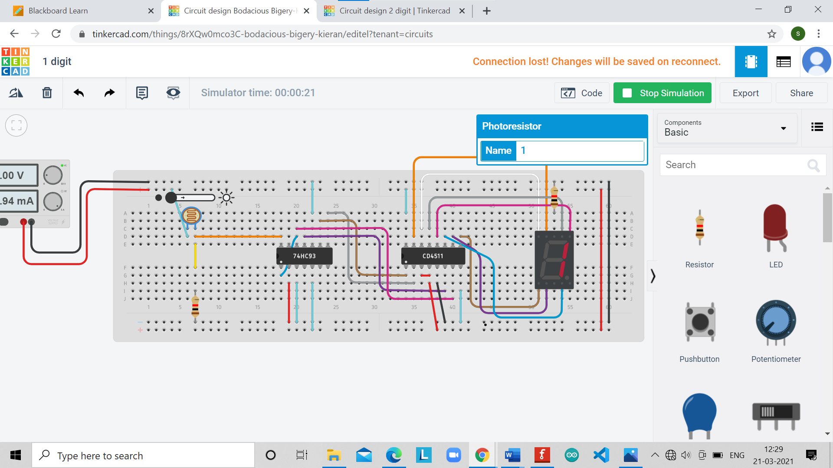

Display of digit 9

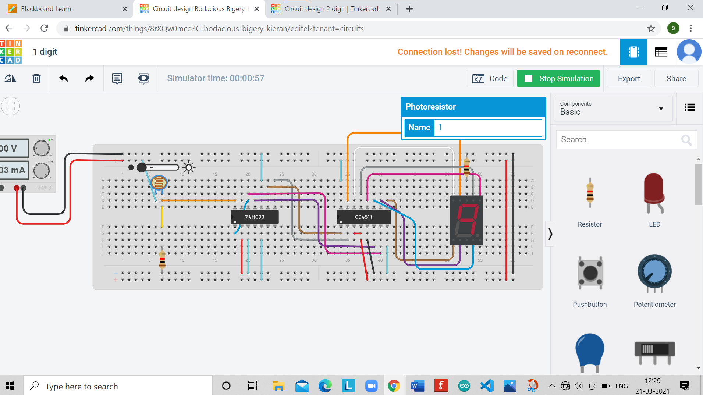

Display of number 15

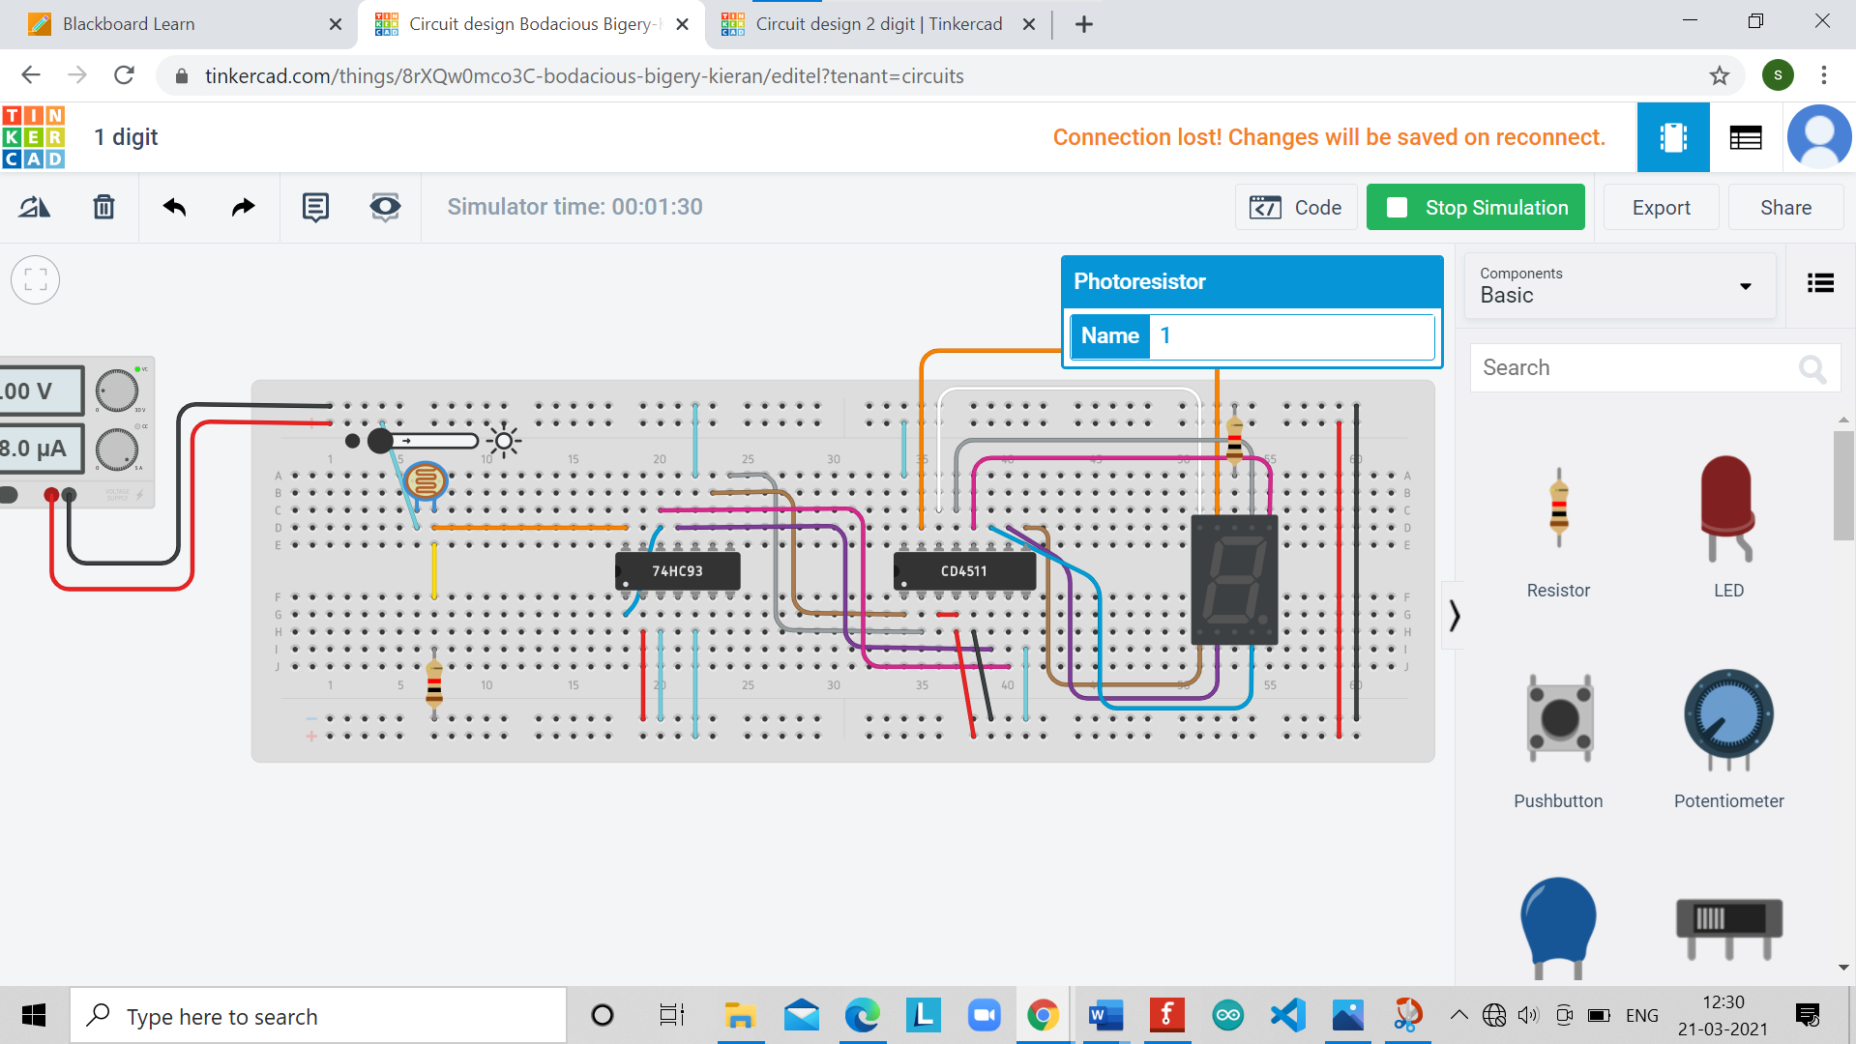

**Concept used**

*(Point out the concepts used in order to design the solution)*

* The object counter is made up of sensor, counter, and display.
* The sensor senses any object that passes in front of it and gives an output pulse to the counter.
* Counter increments count by one when it gets pulse input from the sensor.
* The current count is displayed on any type of display like the 7-segment or LCD display.
* the resistance of LDR is the high voltage across LDR become high.
* As soon as the object crosses the light beam a LOW and HIGH voltage transition occurs, which is given to the Clock (input) of CD4026 IC, it will start to count with the clock and display the count on 7- segment display.

**Learning/ observation**

*(Observations made during the experiment and learnings for future reference)*

* Using photoresistor as senser we can count number of elements in factory, different places for different purposes and different usages..
* This based on When an object is passed between the light beams, the light will not hit on the LDR so the resistance of LDR becomes high.

**Troubleshooting**

*(Problems encountered and how did you solved those)*

* Display of digit not showing because 7segment display at anode that’s why not working .
* I fixed wrong connections output not is showing .

**Result**

The working object counter using LDR, CD4026, and 7-segment was verified on simulation software and implemented on a breadboard.